# *Lab manual 8*

## Lab tasks:

## Name: Muhammad Usman Bhutto.

## Roll no: 453891

## Section: B

## Lab task 1:

#include<iostream>

using namespace std;

int main()

{

float avg,sum=0;

int i,size;

cout<<"enter the size of array:";

cin>>size;

double a[size];

cout<<"enter the elements of array:";

for(i=0;i<size;i++)

cin>>a[i];

for(i=0;i<size;i++)

sum+=a[i];

avg=sum/size;

cout<<"the average of array is:"<<avg<<endl;

return 0;

}

## Output:

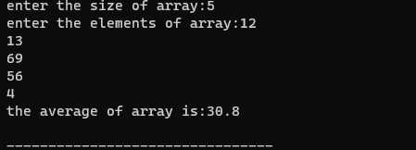

## Lab task 2:

#include<iostream>

using namespace std;

int main()

{

int i,j,size,temp;

cout<<"enter the size of array:";

cin>>size;

int a[size];

cout<<"enter the elements of array:";

for(i=0;i<size;i++)

cin>>a[i];

for (i = 0; i<size ; ++i) {

for (j = 0;j < size- 1 ; ++j) {

if (a[j+1] < a[j]) {

temp = a[j];

a[j] = a[j + 1];

a[j + 1] = temp;

}

}

}

cout<<" the array after bubble sort is:"<<endl;

for(i=0;i<size;i++)

cout<<a[i]<<endl;

}

## Output:

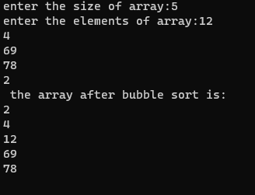

## Lab task 3:

#include<iostream>

using namespace std;

int main()

{

int tot, arr[50], i, j, temp, small, chk, index;

cout<<"Enter the Size of Array: ";

cin>>tot;

cout<<"Enter "<<tot<<" Array Elements: ";

for(i=0; i<tot; i++)

cin>>arr[i];

for(i=0; i<(tot-1); i++)

{

chk=0;

small = arr[i];

for(j=(i+1); j<tot; j++)

{

if(small>arr[j])

{

small = arr[j];

chk++;

index = j;

}

}

if(chk!=0)

{

temp = arr[i];

arr[i] = small;

arr[index] = temp;

}

}

cout<<"\nSorted Array after selection sort is:\n";

for(i=0; i<tot; i++)

cout<<arr[i]<<" ";

cout<<endl;

return 0;

}

## Output:

